February
First Grade-Math
Complete one activity for each day of the month
Day 1  Play this month’s game.  Visit  www.firstinmath.com | Day 2  I started counting backwards from 80 by 5’s. What numbers did I say? | Day 3  How many pieces of the puzzle are white?  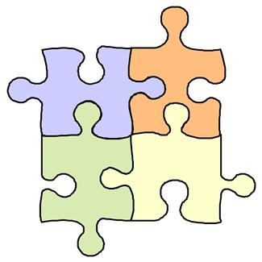Write your answer as a sentence. ion. | Day 4  Which is longer: from your knee to your ankle or from your elbow to the tip of your fingers? How do you know? | Day 5  Who would you predict would have the longest pants in your family? How could check your prediction? | Day 6  Which has a longer side? Name the shape in your answer. | Day 7  Play this month’s game.  Visit  www.firstinmath.com  .
Day 8  Play this month’s game.  Visit  www.firstinmath.com  . | Day 9  Why do you need to use the same non-standard unit to measure an object? | Day 10  How many steps does it take for you to walk from the front door to your bedroom? Estimate, then measure. | Day 11  Use a piece of paper to measure a table in your house. How many units long was your table? | Day 12  Use your pinky to measure the length and the width of a piece of paper. Are your measurements different? Why? | Day 13  How can you tell if a spaghetti noodle or a shoe string is longer? Explain how you measure the two objects. | Day 14  Play this month’s game.  Visit  www.firstinmath.com  ..
Day 15  Play this month’s game.  Visit  www.firstinmath.com  . | Day 16  My mom gave me 20 pieces of candy. I split the candy with 4 of my friends. How many pieces of candy did we all get? Draw a picture and explain your answer. | Day 17  Find a cylinder in your home. Draw and label a picture of the object | Day 18  I started counting backwards from 50 by 5’s. What numbers did I say? | Day 19  Write yesterday’s number is 2 different ways? | Day 20  What number does this represent? Notice the key to the right. | = 10  = 1  Day 21  Play this month’s game.  Visit  www.firstinmath.com
Day 22  Play this month’s game.  Visit  www.firstinmath.com  . | Day 23  I started counting backwards from 30 by 1’s. What numbers did I say? | Day 24  I see three dogs and 2 cats. How many legs did I see? | Day 25  Hold your hand up to an adult’s hand. Whose hand is smaller? How can you describe what you noticed? | Day 26  Count forward from 28 to 29. Write the numbers you said on a piece of paper. | Day 27  Write down these numbers:  11 14 19  Say what comes before and after each number. | Day 28  Day 21  Play this month’s game.  Visit  www.firstinmath.com
22
28
Measurement Game
Players will roll a dice and measure that number of paperclips, skittles, or any non-standard unit of measure on the game board. Each player will mark their ending spot with a marker. The first player to reach the finish circle wins.
START

FINISH

